

PIMA FOUNDATION CELEBRATES CERTIFICATE AND DEGREE GRADUATES OF PIMA COMMUNITY COLLEGE

Students Transition to Pima Alumni and Face Opportunity to Test Career Learning

# MAY 21, 2020

TUCSON, Ariz—Tonight, Pima Foundation and Pima Alumni celebrate the 49th spring graduation convocation of PCC—it will be like no other graduation ceremony Pima Community College grads have experienced. The ceremony will be the inaugural, virtual graduation. Families and fans can follow the 3,400+ members of the class of 2020 and hear from student speakers and other honored guests. PCC Special Events and PCCTV are set for a 6:30 PM countdown and 7 PM start. The Foundation and Pima Alumni contributed to a ‘grad box’ that was mailed to each graduate of the 2020 class.

· **YouTube:** <https://www.youtube.com/watch?reload=9&v=oZK_an5mijc>

· **Facebook:** <https://www.facebook.com/pimacccd>

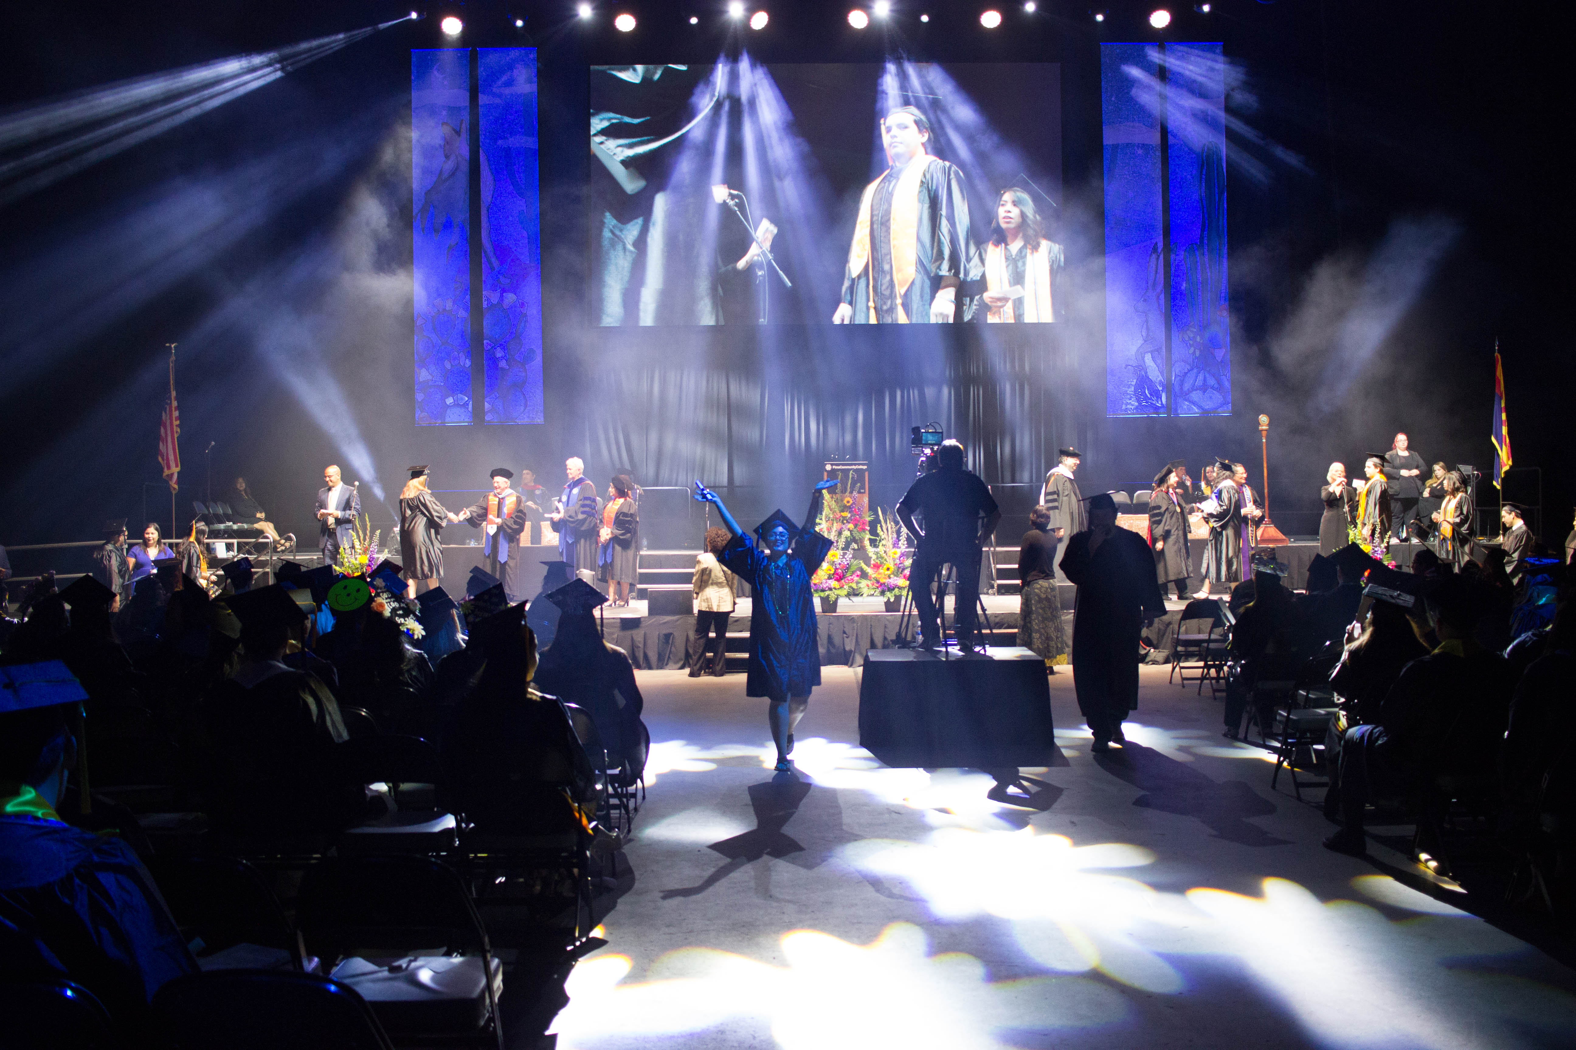

#### **Pima Foundation**, established over 40 years ago, is committed to championing Pima Community College by cultivating relationships for lasting positive impact. The Foundation oversees a variety of endowments and funds for PCC, its programs and students. Community enterprises, families and individuals interested in investing in PCC student success should contact the Foundation for details on donating now and for the future.

###

________________________________

# CONTACT

Marcy Euler, President

Pima Community College Foundation

[Marcy@pimafoundation.org](mailto:Marcy@pimafoundation.org)

520.206.4646 (**O**) 520.603.9382 (**C)**